**Interactive mode with a simple application**

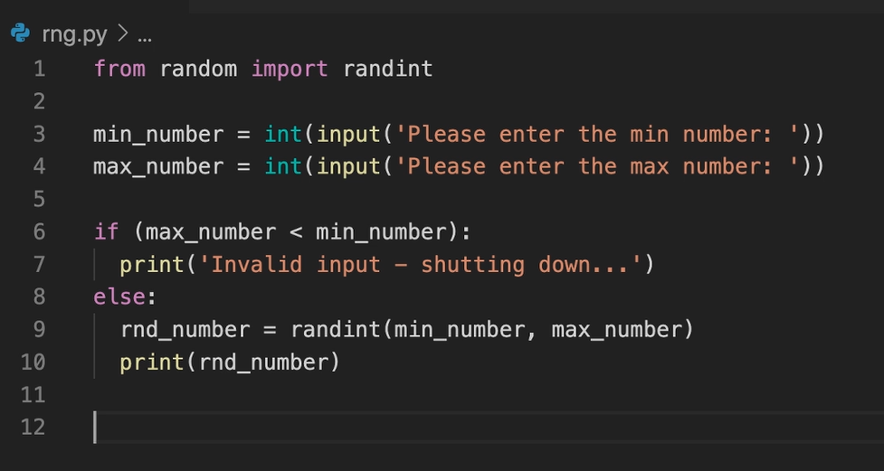

To run the above python code in Docker, let’s write the Dockerfile:

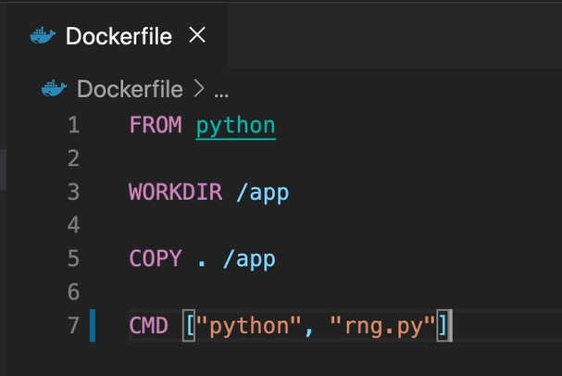

***-i*** is shorter, so we'll use that this keeps standard input open even if not attached which means we will be able to input something in a container. However, typically we combine this with ***-t*** this allocates a pseudo-TTY and, in the end, this means it creates a terminal and therefore if you combine the I and the T flag we are able to input something so the container will listen for our input and we'll also get a terminal exposed by the container which is actually the device where we enter the input.



***-i*** is shorter, so we'll use that this keeps standard input open even if not attached which means we will be able to input something in a container. However, typically we combine this with ***-t*** this allocates a pseudo-TTY and, in the end, this means it creates a terminal and therefore if you combine the I and the T flag we are able to input something so the container will listen for our input and we'll also get a terminal exposed by the container which is actually the device where we enter the input.

